CSD221 Lab 2 W19

[Examples…](http://creately.com/blog/diagrams/uml-diagram-types-examples/)

(<http://creately.com/blog/diagrams/uml-diagram-types-examples/>)

1. Draw the class diagrams for Activities 1, 2, 3 from Lecture 2 and draw the 6 examples at the bottom of lecture 2 using Lucidchart.
2. Create a UML diagram for the following objects  
     
   Note,   
   - all attributes are private.  
   - all behaviours are public.  
   - a Car can have one owner, but a person may own many cars  
   1. Car
      1. Attributes
         1. make
         2. model
         3. year
         4. owner
      2. Behaviours
         1. accelerate(direction)
         2. stop
         3. turn(direction)
   2. Person
      1. Attributes
         1. first name
         2. last name
         3. age
         4. insuredBy
      2. Behaviours
         1. transaction(buy|sell)
         2. walk(direction)
         3. talk(language)
3. Draw an Object diagram showing 2 cars, one with an owner, the other without.
4. Draw an example of a Sequence diagram (see examples above). Show buying and selling of a car. Explain what it shows.
5. Do the JPA Modeller (Netbeans Plugin) Initial Demo pointed to by the URL below.   
     
   Include the demo in your project in a package called lab2.jpaDemo, then push to git.  
   1. <https://www.youtube.com/watch?v=g8B764qNkc0>

Note**   
I created a mysql based version of the demo

Clone it from here:

<https://github.com/SaultCollege/CSD221_Fred_Carella_JPATester_mvn_git.git>

**NOTE** you must create a local MySql database called `jpatester_mvn`.  
Then just run the app.**

Notes**

* Create a database in Netbeans
  + In the “Services” tab of netbeans, right click on MySQL Server and create database, Note grant full access to root

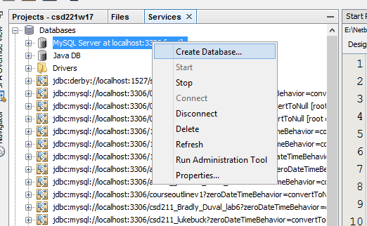  
  
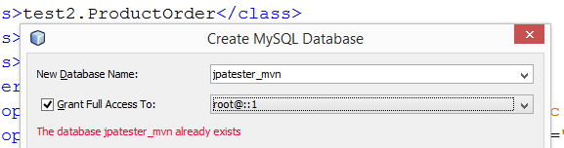

* The JPA Diagram

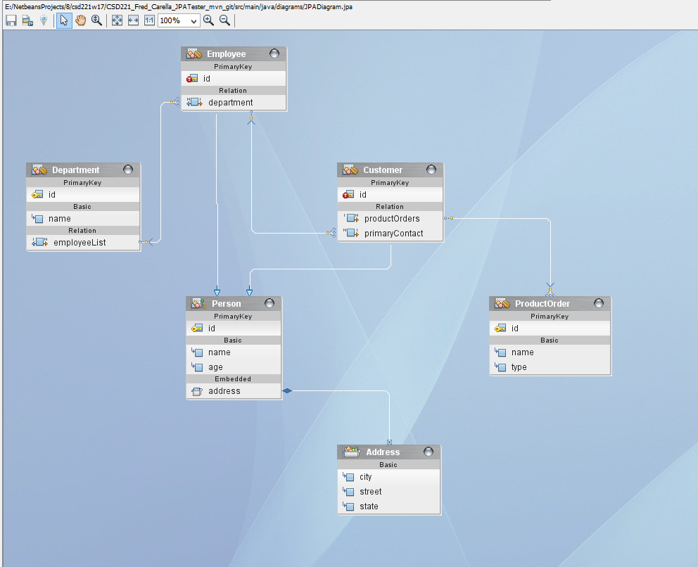

* Right click on the diagram and set the properties like this

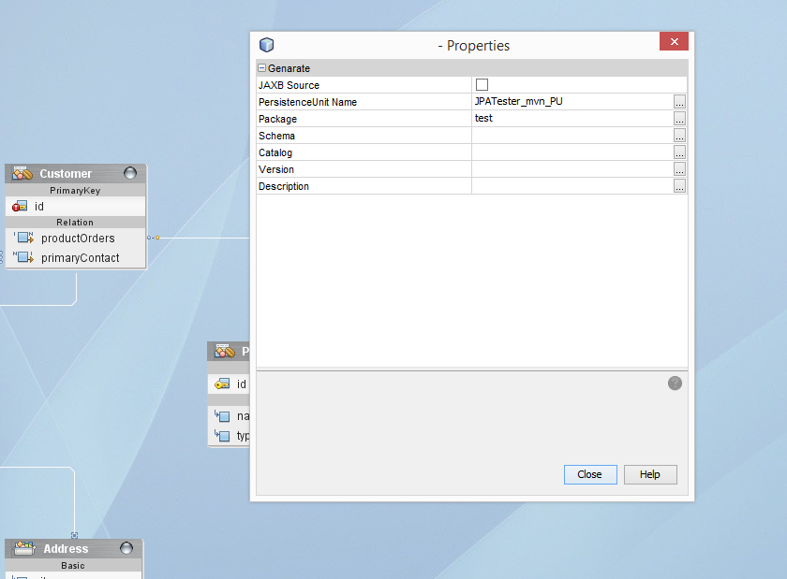

* Right click on diagram and click “Generate Source Code”

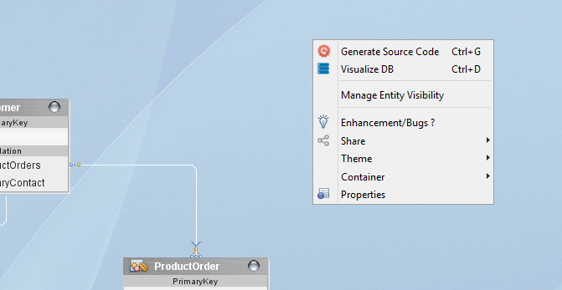

1. Upload this file to LMS assignments.
2. Push your code to the repo.